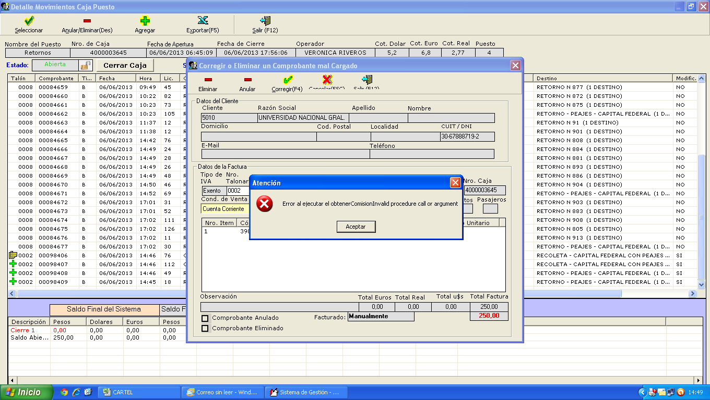

4000003645 9000003132

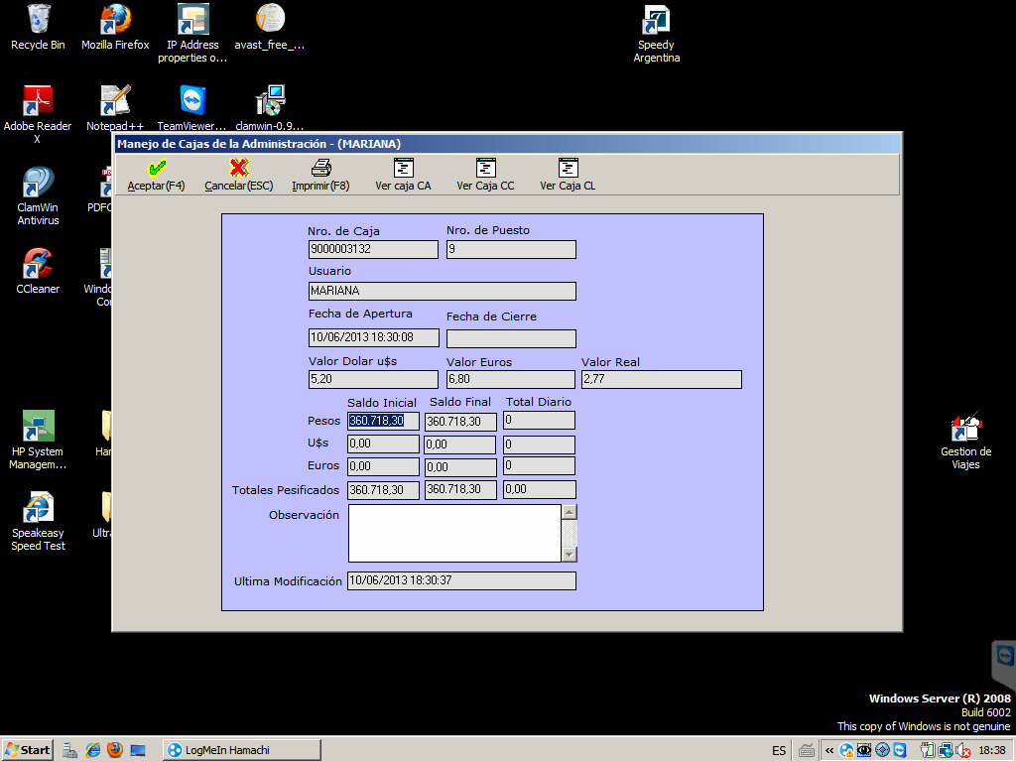

Exec sp_obtenerComision_v4_1 @vlTotalGeneral_param = 250 ,@tpComision_param = 'A Clientes' ,@tpCliente_param = 'A Clientes' @dsCodigoDestinos_param = '390'

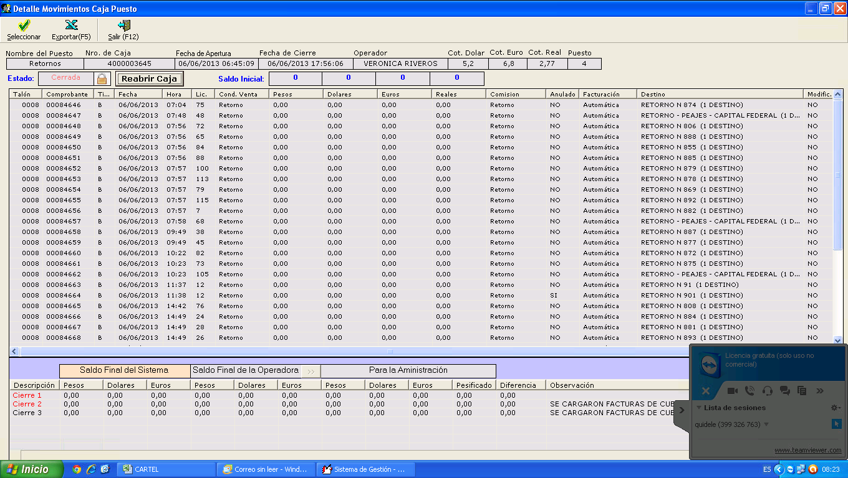

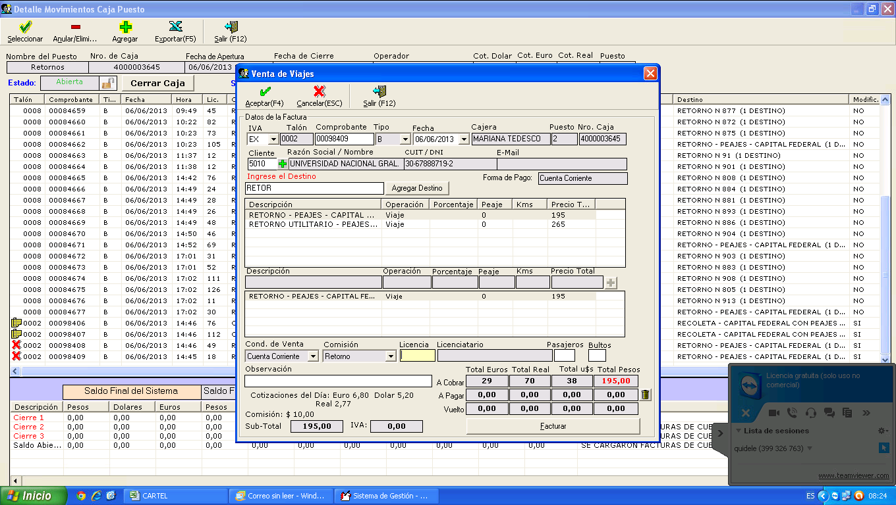|

